
Home
EREC
Members
Publications
Projects
Policy
Events
Renewable Energy House
Renewable Energy Sources
Links

EREC EVENTS

2007 European Renewable Energy Policy Conference
- Online registration  - Conference sponsors  - Hotel Bookings  - First Announcement  - Media partnership | 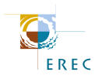
EREC - European Renewable Energy Council - co-organises the 2007 European Renewable Energy Policy Conference together with the German Federal Ministry for the Environment, Nature Conservation and Nuclear Safety in the frame of the German Presidency of the EU.

Date: 29 - 31 January 2007
Venue: Flagey Convention Centre, Place Saint Croix, 1050 Brussels
The conference taking place within the frame of the German Presidency of the Council of the European Union aims at:
- Presenting and evaluating the most important renewable energy policy developments and bringing forward new initiatives
- Facilitating networking between senior decision makers and leading industry players
Organised in Brussels, the conference is expected to attract at least 650 relevant stakeholders from a wide range of backgrounds.
Who Should Attend?
• EU institutions and permanent representations • National governments and local administrations • Energy agencies • Energy regulators and power companies • Renewable energy industries • Utilities and TSOs • Research and academic institutes • Environmental NGOs and consumer groups • Consultancies • Financial institutions and insurance sector
EREC, the European Renewable Energy Council, whose Members are the European industry, trade and research associations AEBIOM, EGEC, EPIA, ESHA, ESTIF, EUBIA, EUREC Agency, and EWEA, represents the entire renewable energy sector.
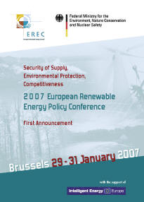 | To access the text of the First Announcement (published in May 2006) click on the pdf icon  (497 KB)
Conference Sponsors
EREC wishes to thank the following sponsors for their support!

 | 

Sponsorship packages are available here. For further information please send an email to conference@erec-renewables.org.
with the support of 
The sole responsibility for the content of this website lies with the authors. It does not represent the opinion of the Community. The European Commission is not responsible for any use that may be made of the information contained therein.
Back to top

